Law changes 26/27
Full presentation

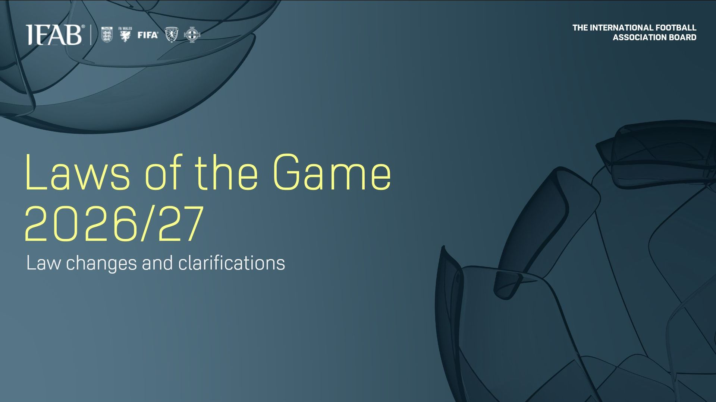

Individual Law changes
Law 3. The Players
- A match may not start or continue if either team has fewer than seven players, except where this is temporary because of a temporary dismissal or where the ‘Time-limited substitution protocol’ or ‘Off-field treatment and assessment protocol’ applies; where a team is responsible, it will, in principle, forfeit the match (Additional change - approved on 28 April 2026)
- Number of substitutes that may be used in senior ‘A’ international team friendly matches increased to eight, or to eleven if both teams agree and inform the referee in advance; the restriction to three substitution opportunities per team will apply
- Ten-second time limit for players to leave the field of play when being substituted. If the time limit is exceeded, the substitute cannot enter until the first stoppage after one minute has elapsed
- Advance notice:
‘Only the captain’ guidelines will become a compulsory protocol for all competitions as from 1st July 2027

Law 4. The Players’ Equipment
- Accessories are permitted if they are not dangerous and if safely and securely covered

Law 5. The Referee
- Competitions are permitted to use technology to help the referee make/change decisions in relation to the video assistant referee (VAR) protocol, ball in/out of play (including goal line technology) and offside (including semi-automated offside technology)
- Clarification that the advantage may be applied when a restart is incorrectly taken and the ball is in play
- Barring certain exceptions, players who receive assessment/treatment on the field of play or who cause play to be stopped due to injury must leave and remain off the field of play for one minute after play has restarted
- VAR may review:
  - an incorrect red card resulting from a clearly wrong second yellow card
  - a player wrongly being shown a red or yellow card when the offence was committed by another player of either team
  - a wrongly awarded corner kick if the decision can be changed immediately and without delaying the restart (competition option)
- Competitions have the option of providing referees, assistant referees and fourth officials with body cameras
- Accessories are permitted if they are not dangerous

Law 6. The Other Match Officials
- Additions to VAR-reviewable incidents

Law 7. The Duration of the Match
- An abandoned match is replayed unless the competition rules or organisers determine otherwise; where a team is responsible, it will, in principle, forfeit the match (Additional change - approved on 28 April 2026)

Law 8. The Start and Restart of Play
- Dropped ball text amended to clarify that the team that ‘would have gained possession’ includes the team that would have taken the restart in situations where the ball would have gone out of play. When there is interference by a match official or outside agent, the ball is dropped at the position of the interference

Law 10. Determining the Outcome of a Match
- Confirmation of circular no. 31 concerning accidental double touches during penalties (penalty shoot-out)
- Removal of the automatic caution (YC) for the kicker if they and the goalkeeper offend at the same time

Law 12. Fouls and Misconduct
- No caution (YC) for a DOGSO offence if the advantage is played and a goal is scored
- Reference to ‘attackers’ added to the list of considerations for DOGSO
- Competition option (Additional change - approved on 28 April 2026):
  - A player, substitute or substituted player is sent off if they cover their mouth when communicating with an opponent in a provocative, derisory or inflammatory manner or situation
- Competition option (Additional change - approved on 28 April 2026):
  - A player who leaves the field in protest at a referee decision is sent off
  - A player, substitute or team official who instructs or encourages players to leave the field in protest at a referee decision is sent off

Law 14. The Penalty Kick
- Confirmation of circular no. 31 concerning accidental double touches at a penalty kick
- Removal of the automatic caution (YC) for the kicker if they and the goalkeeper offend at the same time

Law 15. The Throw-in
- Use of a five-second visual countdown when a player/team is delaying the taking of a throw-in. If the time limit is exceeded, the throw-in is awarded to the opposing team

Law 16. The Goal Kick
- Use of a five-second visual countdown when a player/team is delaying the taking of a goal kick. If the time limit is exceeded, a corner kick is awarded to the opposing team

Law 17. The Corner Kick
- A corner kick may be awarded when the referee penalises a goalkeeper for holding the ball for too long or a team for delaying their goal kick.

Video assistant referee (VAR) protocol
- Red cards resulting from a clearly incorrect second yellow card reviewable
- Mistaken identity reviewable when a player is shown a yellow/red card but the offence for which the card was shown was committed by another player of either team
- Competitions have the option of reviewing corner kicks that have clearly been incorrectly awarded if the decision can be corrected immediately and without delaying the restart

