Welcome to the WYSL Fall 2025 Season!
Inbox

Ref Insight <news@mail.refinsight.com> | Tue, Sep 2, 12:23 PM (2 days ago)
to me

From: Victor Borges - Eastern New York Soccer Referee Association
Hi everyone,
Welcome to the Fall 2025 season!
Below is some very important information for this season:

Ref Insight
The WYSL will use Ref Insight as the official assignment platform.
They maintain a helpful tutorial library here:
Ref Insight Tutorials

Self-Assign
Small-sided centers and some 11v11 assistant referee slots are available for self-assigning.
These open at midnight on Monday for the following Sunday.
Exception: For the first week only, self-assign will open Tuesday at midnight.

Availability
For referees eligible to work older age groups as CENTER referees, please complete this availability form:
WYSL Availability Form
Submit your availability for each weekend you are available.
If your availability changes, simply submit a new form — your latest entry will be used.

Game Reports
All center referees must submit a game report in Ref Insight after each match.
Instructions: Completing Match & Incident Reports
Reports are due by Monday at noon following your game.
If not submitted on time, your crew’s payment will be delayed until the following week.

Payments
To be paid, you must complete the referee payment form (if you did not already do so in Spring 2025):
WYSL Payment Form
Payments will be processed by Thursday, provided your report is submitted on time (Monday noon deadline).

Game Fees
Game fees for Fall 2025:
U17/U18 – $130 / $85 / $85
U15/U16 – $120 / $80 / $80
U14/U13 – $110 / $70 / $70
U11/U12 – $85 (single referee)
U9/U10 – $75 (single referee)

WYSL Assignors
The WYSL assigning team is divided by coverage area. Please see contacts below:
Victor Borges – assignor@wyslsoccer.org (All of WYSL)
Joseph Carbone – josephcarbone9@gmail.com (Bedford, Briarcliff, Cortlandt, Croton, FC Transylvania, John Jay FC, North Salem, Pleasantville, Shrub Oak)
Rich Decola – rich@mahopacsoccer.com (Mahopac SC)
John Hayes – jjh23roma@gmail.com (Yorktown Youth SC, FC Somers)
Daniel McEnery – rvsoccer1@aol.com (East Ramapo SA, FC Spring Valley, NY Phoenix, NY Soccer Club)

Rules of Competition & Points of Emphasis
The WYSL rules of competition and seasonal points of emphasis will be sent out in the coming days.

I’m looking forward to another great season with all of you!
As always, please don’t hesitate to reach out with any questions.
All the best,
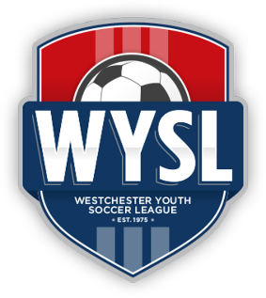 | Victor Borges, Director of Officials  Westchester Youth Soccer League  32 Elm Place, Suite 1S, Rye, NY 10580  Office: +1 (914) 235-4110 x2004  Cell: +1 (914) 410-7681 | www.wyslsoccer.org

