WYSL - Fall 2024 - Important Information

From: Ref Insight (news@mail.refinsight.com)

To: pieroolcesesr@aol.com

Date: Monday, September 2, 2024 at 02:52 AM EDT

From: Victor Borges - Eastern New York Soccer Referee Association Hi everyone,

It's crazy to believe the Fall 2024 season is right around the corner! It’s been a while since most of us were last out on a field, but here is an attempt to make it all happen again!

Below is some very important information that will come in handy for the season:

-----------------------------------------------------------

**Ref Insight:**

The WYSL will use Ref Insight as the only official assignment platform. They have a library with tutorials (below) and are constantly adding to it:

<https://refinsightllc.freshdesk.com/support/solutions/151000209140>

**Self-Assign:**

There are small-sided centers and some 11v11 assistant referee slots available for self-assigning. These become available at midnight on Sunday for the following Sunday.

Below is a video tutorial on how to use this feature: <https://www.youtube.com/watch?v=NPB30ryZDqs>

**Availability:**

For those referees who work older age group matches as CENTER, please use this form for availability:

<https://forms.gle/dgRFqbGzMNFGn461A>

Please input your availability for the two weekends following the date of submission. This means you will have to submit two separate entries. I look at these entries on Sunday nights and will **try** to assign games two weekends in advance by Monday night. You DO NOT need to submit this form if you primarily self-assign (see below).

**Game Reports:**

In order to be paid for your matches, you must complete a game report via Ref Insight.

Instructions on how to do this can be found here: <https://refinsightllc.freshdesk.com/support/solutions/articles/151000183934-completing-match-and-incident-reports>

**Payments:**

In order to be paid for your matches, you must have a Ref Insight Pay account set up. Instructions on how to do this can be found below:

[https://refinsightllc.freshdesk.com/support/solutions/articles/151000189612-ref-insight-pay-enter-or-update-your-bankand-tax-id-information](https://refinsightllc.freshdesk.com/support/solutions/articles/151000189612-ref-insight-pay-enter-or-update-your-bank-and-tax-id-information)

Every effort will be made to pay you by Wednesday as long as your game report has been submitted by Monday morning.

**Game Fees:**

Below are the game fees for Fall 2024:

· U17/U18 - $125/$80/$80

· U15/U16 - $115/$75/$75

· U14/U13 - $105/$65/$65

· U11/U12 - $80 (single ref)

· U9/U10 - $70 (single ref)

**WYSL Assignors:**

The WYSL assigning team will consist of a few assignors spread across different areas of coverage. See below a list of all assignors, their contact information and areas of coverage:

Victor Borges

assignor@wyslsoccer.org All of WYSL

Joseph Carbone

josephcarbone9@gmail.com

All of Bedford, Briarcliff, Cortlandt, Croton, FC Transylvania, John Jay FC, North Salem, Pleasantville and Shrub Oak home games

Rich Decola

rich@mahopacsoccer.com All of Mahopac SC home games

John Hayes jjh23roma@gmail.com

All of Yorktown Youth SC and FC Somers home games

Daniel McEnery rvsoccer1@aol.com

All of East Ramapo SA and FC Spring Valley, NY Phoenix and NY Soccer Club home games

**Rules of Competition & Points of Emphasis:**

The WYSL rules of competition and important points emphasis will be sent out in the coming days.

----------------------------------------------------------- I am looking forward to another great season with you all!

As always, if you have any questions, feel free to reach out.

All the best,

Victor Borges

**Victor Borges,** Director of Officials

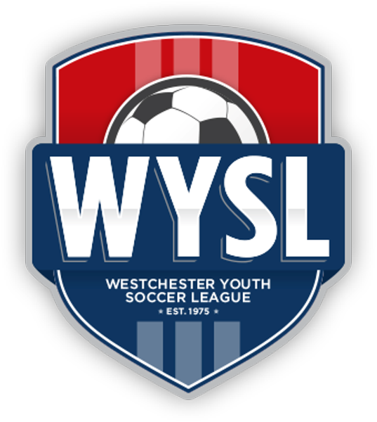**Westchester Youth Soccer League**

32 Elm Place, Suite 1S, Rye, NY 10580

Office: +1 (914) 235-4110 x2004

Cell: +1 (914) 410-7681 | [www.wyslsoccer.org](https://wyslsoccer-org.jmailroute.net/x/d?c=39920168&l=f86b41cf-9eb9-487a-955d-e3398460b8f3&r=91ff8261-92f4-42b1-858a-cf514a9a555d)

